

**ASSIGNMENT - 1**

**Computer & Networks**

**M. Sumanth Reddy**

**Av.****en.u4aie22020**

**AIE-A**

**Submitted to: Dr.Raj Kumar**

**1.Create a Campus Network using different Topologies**

**Intro:**

A Campus Network contains many of Switches, Pc’s, Laptops, Routers and also divided into a minimum number of blocks that actually look like actual Campus Design. And this Campus Network Project contains of **Block A, Block B, Block C** and **Admission Block** and these are all Interconnected each other by routers with provides the Data transfer for every Device in the Network Radius within a High speed.

In this Campus Network **Block A** contains of 5 Pc’s, 2 HUB’s, one switch and Router.

**Block B** contains of 3 Pc’s, 1 Laptop, 5 Switches, and Router.

**Block C** contains of 3 Pc’s, 1 Laptop, 5 Switches and Router

**Server Room** contains of 7 Switches, 4 Pc’s, 1 Laptop and Router

**Apparatus:**

In this Campus Network Project, we had used:

 **Switch:** The Switch is used to Connect between two devices and here we have used **2960-24TT** and it consists of 24 ports which means we can connect 24 devices for single Switch which is widely used in Lab, Industrial Purposes.

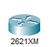**Router:** The Router is used to provide the Internet for the following connected devices. In this network we have used 2621XM model router because it consists of 4 Serial Connection ports which makes us easy to connect with every other routers in every possible way.

**Pc:** The Pc is an end device, used as receiver and sender of Packets in this network and by transferring the packets from one Pc to another Pc we can declare working status of the Network.

**Laptop:** Laptop is also an end device, work as same as Pc for Transferring the Packets from one Laptop to another Laptop.

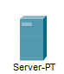 **Server:** Server is a device which works as a middle end device for Internet and end devices and it handles the working progress for different devices.

**Pt-Hub:** Pt-Hub is a network device and also a multiport repeater that forwards any traffic to all the ports and reduces bandwidth.

**Twisted Breaker Wire:** Used to connect the same devices in the Network.

**Twisted Straight Wire:** Used to Connect the different devices in the Network.

**Serial Wire:** Used to Connect the one router with another router.

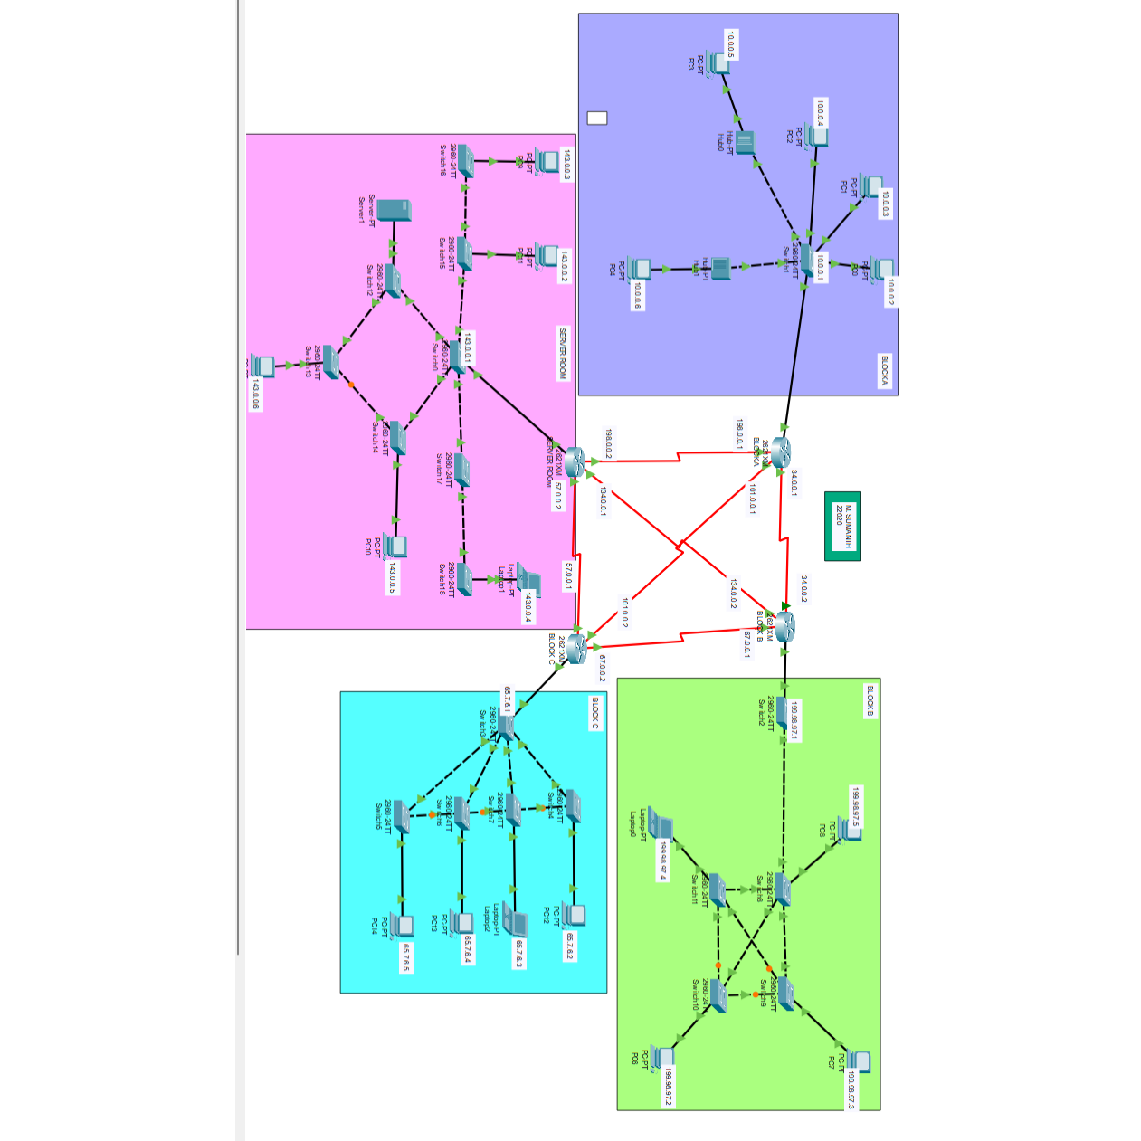

**Construction Of Network:**

**Block A:** In the construction of Block A we have used 5 Pc’s, 1 switch, and 2 Hub and to connect these all devices we need to go into desktop of a PC and pick a IP address as 10.0.0.2 for one Pc and serially for other Pc’s, also and we have to declare one IP address as Default Gateway [10.0.0.1] and enter into every Pc’s default Gateway and we have to connect the every Pc with the Switch at the last we have to enter the Default Gateway in the FastEthernet0/0 of the Router of Block A.

And by taking the 3 random IP address and that to be entered into Serial0/2[198.0.0.1] and   
Serial0/0[34.0.0.1] and Serial0/1[101.0.0.1].

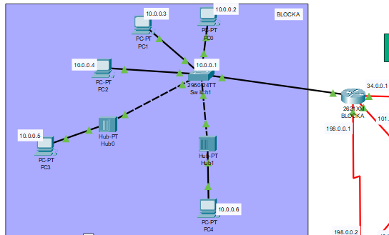

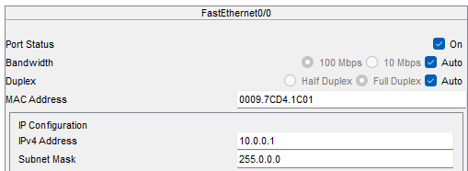

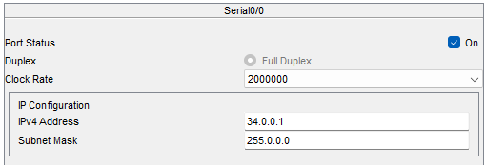

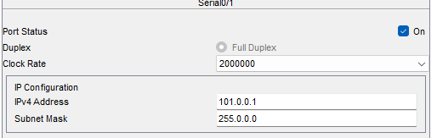

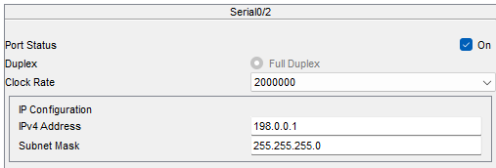

**Block B:** In the Block B we have used mesh topology to construct, and it consists of 3 Pc’s, 1 Laptop, 6 switches and Router. In this Block every switch is connected with every switch in this Block. And we have to give IP address by opening the Pc and selecting the Desktop and type the IP address as 199.98.97.2 and using this type serially to all other Pc’s and also below the IP address there is also Default Gateway and type 198.98.97.1 which must be type same in the Default Gateway of every other PC in this Block.

And the same Default Gateway [199.98.97.1] to be entered into the FastEthernet0/0 of Router of Block B, and also take 3 IP addresses and enter 34.0.0.2 in Serial0/0, 67.0.0.1 in Serial0/1 and 34.0.0.2 in Serial0/2.

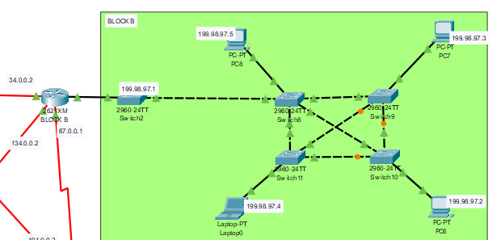

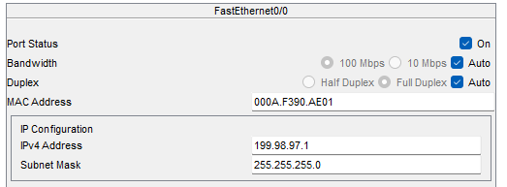

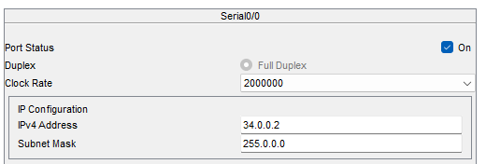

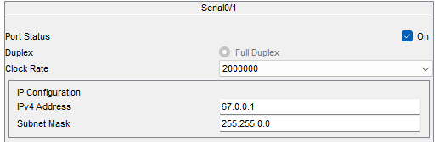

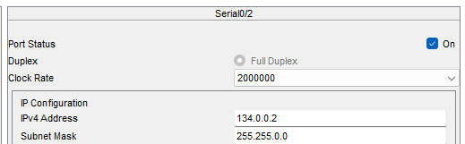

**Block C:** In the Block C we have used Bus Topology to build the Block and we have used 5 Switches, 4 PCs and 1 Laptop and connect the each Pc with each switch and connect the switches with each other and connect it to the Router of Block C. and take a IP address of 65.7.6.2 for one Pc and give the serial of IP address for remaining Pc’s and Take a Default Gateway of 65.7.6.1 to be entered into every PC and make sure that everything is entered. And take the Default Gateway and enter it into the FastEthernet0/0, 67.0.0.2 in Serial0/0, 67.0.0.1 in Serial0/2 and 101.0.0.2 in Serial0/1.

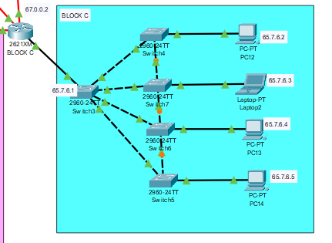

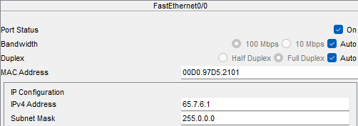

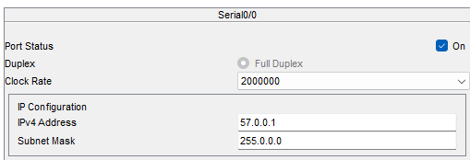

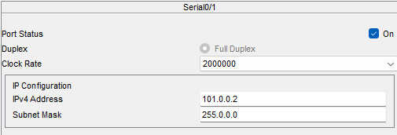

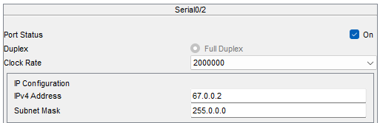

**Server Room:** The Server Room is a part of the Campus Network is inspired from Hybrid Topology and it is a block of network, and it consists of 8 switches,1 Server, 3 Pc’s, 1 Laptop and Router. After connecting the Switches with Pc’s and also each Switch with each other. After that given connection to router. And go to Desktop Option in Pc and type a IP address of 143.0.02 and type serial of that for the remaining Pc’s and below the IP address type the Default Gateway as 143.0.0.1 for every Pc’s and also assign the IP address and Default for the server also

And now type the Default Gateway in the FastEthernet0/0 in Router, 198.0.0.2 in Serial0/0, 134.0.0.1 in Serial0/1 and 57.0.0.2 in Serial0/2.

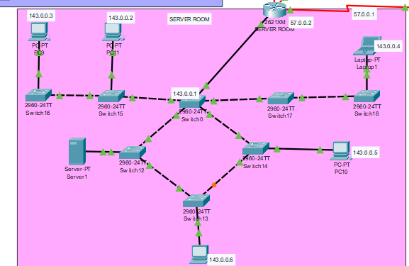

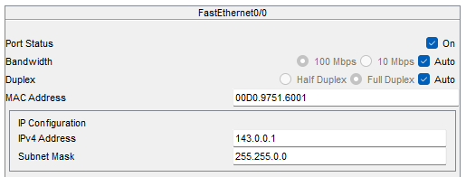

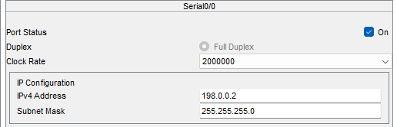

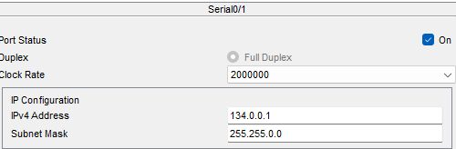

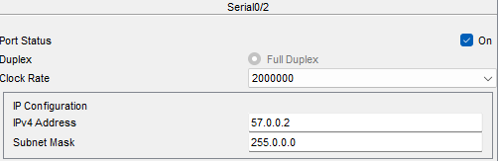

**Procedure:** Step by Step of Building the Connection the Campus Network

* Firstly, open the Desktop of Pc and assign the IP address and Default address and give the same serial number of other Pc’s in same block of network and give the Default Gateway for every Pc and the same Gateway for FastEthernet0/0
* Now do the same for every block of Network for Block B, Block C, Server Room
* Now connect each router using the serial connection and one router must connect every other router.
* Take the 3 IP addresses in same Serial Wire and assign them in Serial0/0, Serial0/1 and Serial0/2 which are 3 serial connections connect with single router. And make sure that turn On every connection which contains the IP addresses.
* Now, using the IP addresses entered into the Serials Open the Config mode in Router select Static mode and we can see there are three fields as Network, Mask and Next Hop.
* Now start doing Static Routing, Network as any direction of other Block IP address at the end it must contain 0[12.21.23.0]. And Mask as 255.255.255.0 and Next Hop it means the IP address of Serial connection beside the Router what we are doing Routing.
* Samely, Do the static routing for every other Possible way for transfer of Packets in both directions because if we remove connection in direction it must able to travel in another direction and there is a third direction which connects the Router diagonally with another Router.
* Do this every possible way every router and we can get 7 Static Routing for each Router.
* After finishing that once again check the IP address entered correctly or not for every Pc, Router.
* To make sure that Network work we must run the Packet from One PC of Block to another Pc of another Block.
* For the first time it fails because it must understand the way and run again for same devices it will run successfully, if not something went wrong and check all the inputs.

**Adding Addresses for Router:**

For Adding the addresses of Router if the device is connected for single Fast Ethernet, we need to enter only one.

Now in above network there is only one connection, so we open the config mode in the Router and enter the Default Gateway of the Block into the FastEthernet0/0

After entering it then there are 3 IP addresses around the Router which connecting the other 3 routers, then enter each address for the Serial connection.

Suppose I had taken Block A router then I must enter 10.0.0.1 as FastEthernet0/0, 34.0.0.1 as Serial0/0, 101.0.0.1 as Serial0/1 and 198.0.0.1 as Serial0/2 and switch On every connection.

If the green upper arrow presents between the connection, then it represents the connection is On or else if red it is Off

Now, Repeat the same process for every Router to assign the addresses.









**Static Routing:**

How to do Static Routing.?

To do static routing in the routers we to select the static option which was present in the config mode of router.

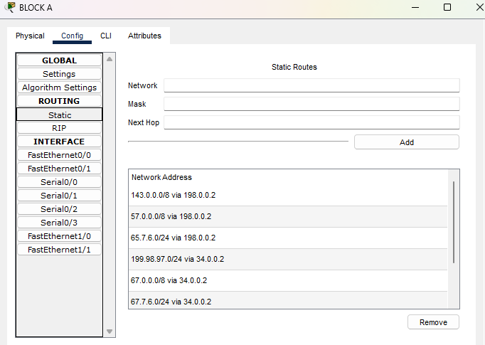

After that we give the IP address for each router and each Serial connection contains 2 IP addresses and they will be in serial and the IP addresses will be written in Serials connections.

And we have to observe the connection between the 4 Routers and open the Static mode and click

**Network:** address of receiver for transfer of Packet

**Mask:** if number contains, we will write 255 or 0

Suppose 11.23.0.0 -> 255.255.0.0

**Next Hop:** The next address of Router beyond its address.

After entering the above values in one router and click on add, same as we have to do one router with every router with every possible way of transferring the packets.

And we can also delete the Network Addresses using remove click.

**Detailed info of Static routing for every Router:**

**Router 0:**

In the Static Routing we must pick a Router first which we need to do routing after that as we before given the IP addresses for the 3 Serial connections.

By using that we need to pick a direction for routing and after that we have to write Default gateway of that block, but ending is 0

For example, 23.4.2.3 as 23.4.2.0

After that enter the Mask as if there is number in Network enter 255 or else 0 and then between the two blocks there is 2 IP addresses on Serial Connection, the second one to be enter into Next Hop after completing that we need to turn the direction for another Block so then there is a another IP address on Serial Enter it into network and next-hop was same

And write the Block’s Network address

After completing the visiting every router in one direction do the same in another direction and do another which the sender router connected diagonal to another Router

In the changing direction, everything remains same as the network we did before in one single but Next Hop changes when we are doing in the second direction.

Now do the same for every Router

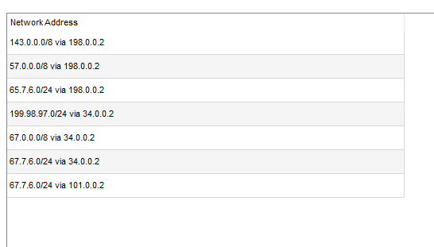

**Router 1:** As same procedure above

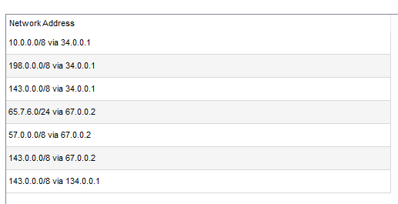

**Router 2:** As same procedure above

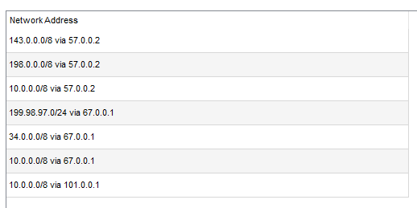

**Router 3:** As same procedure above

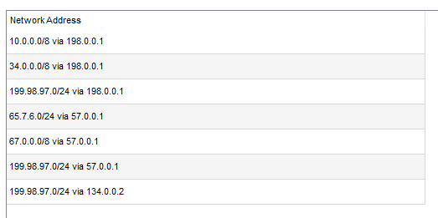

**Transferring the Packets:**

By transferring the packets, we can know that much about the Network and how it works and there is an any problem any connection and we can rectify it. In below we had assigned the packets for two different Pc’s and the travelling packets and the switch will send the different packets for every Pc with the unique receiver ID the Pc will respond and it will resend back the packet to the sender, and it will be successful .

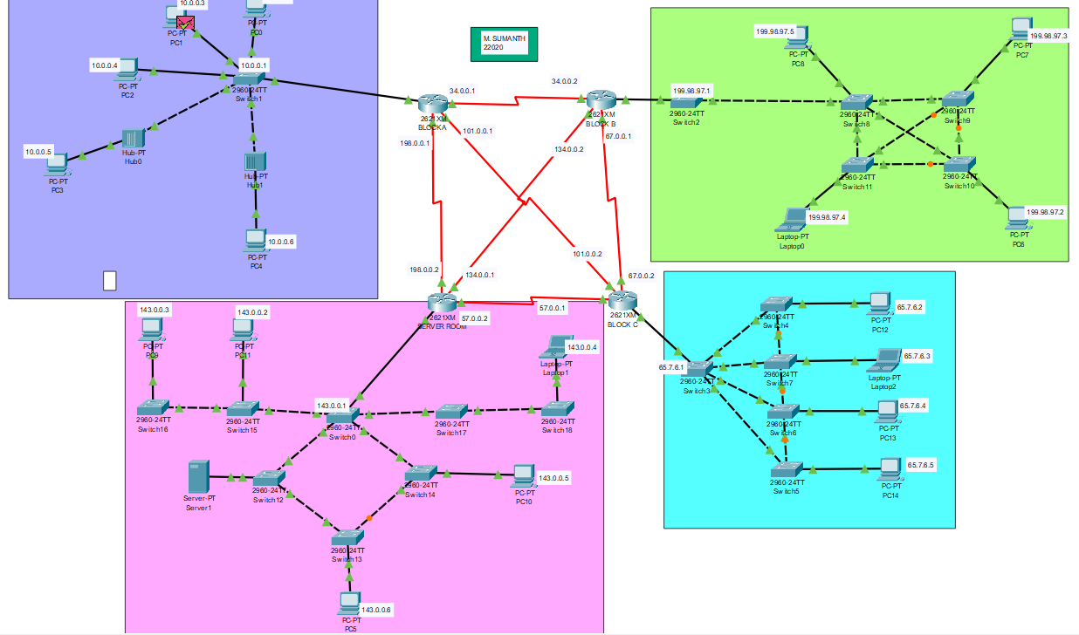

**RealTime mode:**

RealTime shows the packets that has travelled from one Pc to another Pc is successful or failed.

If there is a valid connection between the Pc’s it shows Successful or else if connection is interrupted it shows failed.

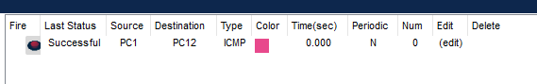

**Simulation mode:**

If provides the detailed information about the packet from which it travels from one switch to another switch and provides the detailed info about time taken from switch to switch and packet which is at present device.

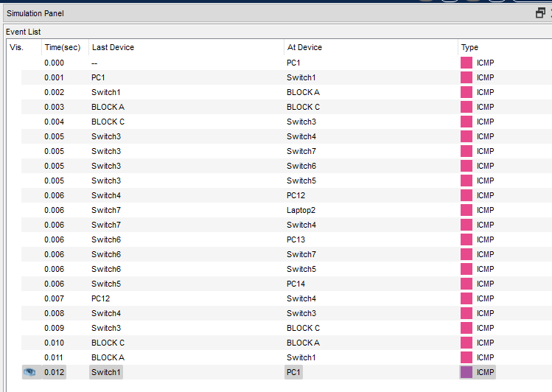

**After Removing Connection b/w Routers:**

In the below I had 3 connections of Routers and I had done the transferring the packets.

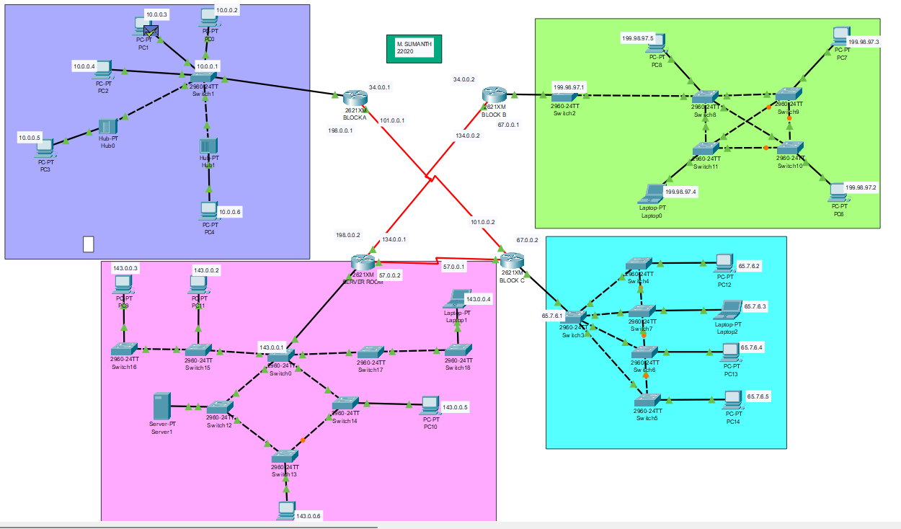

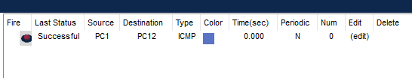

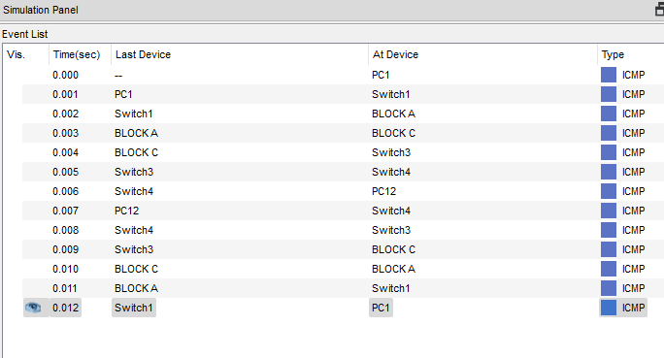

**Ping:**

By using Ping, we can check the connection from the one pc to another pc by using IP address and it display the time taken to connect and show no of packets have been transferred, received and lost while transferring.

In Some cases, due to some network issues the packets which was will be lost.

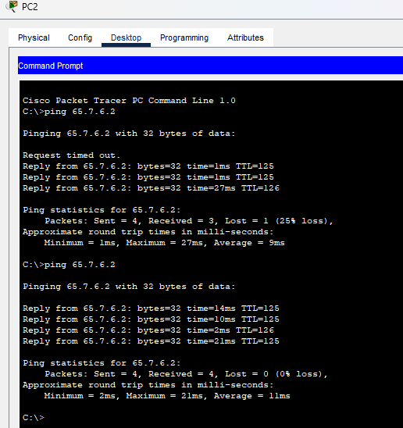

**Pros:**

* It is economical, as it uses fewer cables, switches, hubs, and routers than connecting each LAN separately to the internet.
* It offers high-speed data transfer within the network, as it uses LAN technologies and optical fiber media.
* It can use the same internet service provider (ISP) for all the connected LANs, reducing the cost and complexity of managing multiple ISPs.

**Cons:**

* It is expensive to maintain and troubleshoot as it requires more hardware and software than a LAN
* It may have undesirable interactions or interference among the nodes, as they share the same network medium
* It may have security issues, as it exposes the data and resources of the connected LANs to external threats. It requires firewall or proxy server to protect the network from unauthorized access

**Observation:**

In CAN network we have observed that when we removed the 3 connections then also using fourth serial connection the Network works perfectly and it also very complex because of static routing. If multiple nodes try to transmit a message onto the CAN bus at the same time, the node with the highest priority (lowest arbitration ID) automatically gets bus access. Lower-priority nodes must wait until the bus becomes available before trying to transmit again. In this way, you can implement CAN networks to ensure deterministic communication among CAN nodes.

**Positive Cases:**

In this case we will run the packets from the one block to another block to make sure that Network is working properly.

**Case1:** Here I had transformed from Block A to Block B we can see there is Source is PC1 and destination is PC7 which is in Block B and it runs successfully

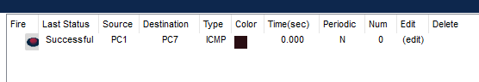

**Case2:** In this part I had transformed packets from Block A to Block C we can see there is Source is PC1 and destination is PC12 which is present in Block C and it runs successfully

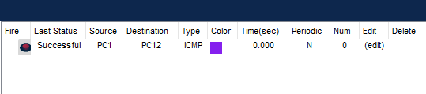

**Case3:** In this I had transformed packets from Block A to Server Room and we can see that there is Source is PC1 and Destination is PC11 and it also runs successfully.

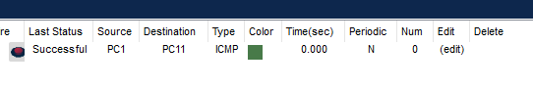

**Negative Cases:**

**Case1:** In this case I transferred the packets from Block A to Server Room in this I had removed the connection between thePC 1 to PC11 with the switch and it remains Fails.

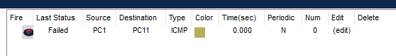

**Faulty Case:**

In the CAN network the failing of the network is very less because it was built with complexity and because of Interconnection of the routers with every router so with using single router also we can run the connection perfectly.

And there is a case of failing.

* By removing all possible connections to router
* Entering the wrong IP addresses
* Or else Power is off

In the below case I had removed the connection for the Block C router in every possible way and I had done the transferring the packets and it results the fail.

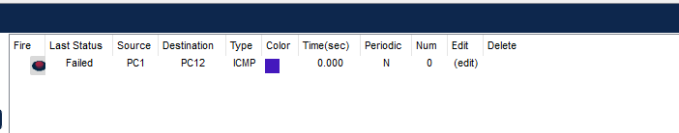

In case of Failing the total network may not work and specific Topology will stop working and remaining Topologies will work

**Conclusion:**

In this complete Campus network, we had taken 4 Blocks for the Networking. And because of doing static routing in every possible way, we can run the packets from the removing the connection on one side and by removing the connections on the 3 sides by using the diagonal connection it can transfers the Packets successfully.